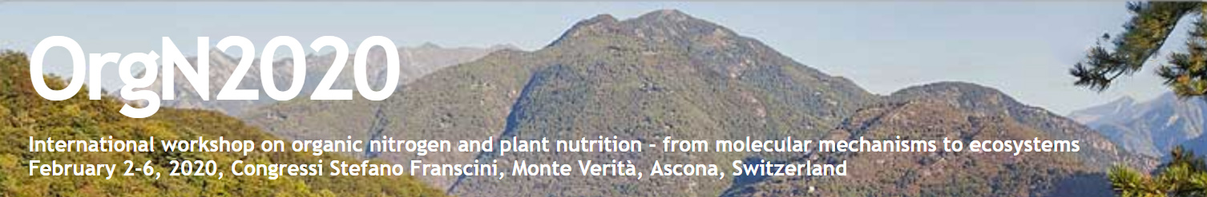
Abstract form
Please safe as „Presenting author last name_first name.docx“ and send as email attachment to: OrgN@ips.unibe.ch
Please insert your abstract (approx. 200 words) into the blue frame provided, using the example given in the next paragraph, and underline the contributing author. Note that your abstract will be printed exactly as it appears below. Please indicate whether the abstract should be considered for an oral presentation or a poster, and into which session(s) it fits best.
☐ Oral presentation
☐ Speed talk (this option is available only for early career researchers)
☐ Poster
☐ Session I: Presence and availability of organic N in soils
☐ Session II: Uptake of organic N from the rhizosphere
☐ Session III: Organic N metabolism and transport to storage organs
☐ Session IV: Learning from regulatory N networks at the molecular and global scale
☐ Session V: Organic N in agriculture
☐
☐ Presentation (oral or poster) is eligible for the CSF award (max. age 33, PhD student or less than 3 years postdoc in February 2020)

☐ Single room preferred (if available)
☐ Shared double room (twin beds)

Doris Rentschª, Susanne Schmidt^{b}, and Torgny Näsholm^{c}.
ª Institute of Plant Sciences, University of Bern, Bern, Switzerland
^{b} Institute/Department, University, City, Country
^{c} Institute/Department, University, City, Country

Organic N produced by plants ensures survival of conference participants.

Based on field studies in Ascona organic N was shown to be essential for a good mood and optimal performance of plant scientists. We show here that reguarly provided organic N counteracts the negative effects of ....

